Login Directions for New Users of TRAIN

Train Massachusetts (TRAIN MA), an affiliate of the TRAIN Learning Network, is a free online learning platform that provides on-demand training on various public health topics. It is available to all public health professionals in Massachusetts, including those just starting their careers.
Login directions for new users of TRAIN Massachusetts.
- Visit the Website:
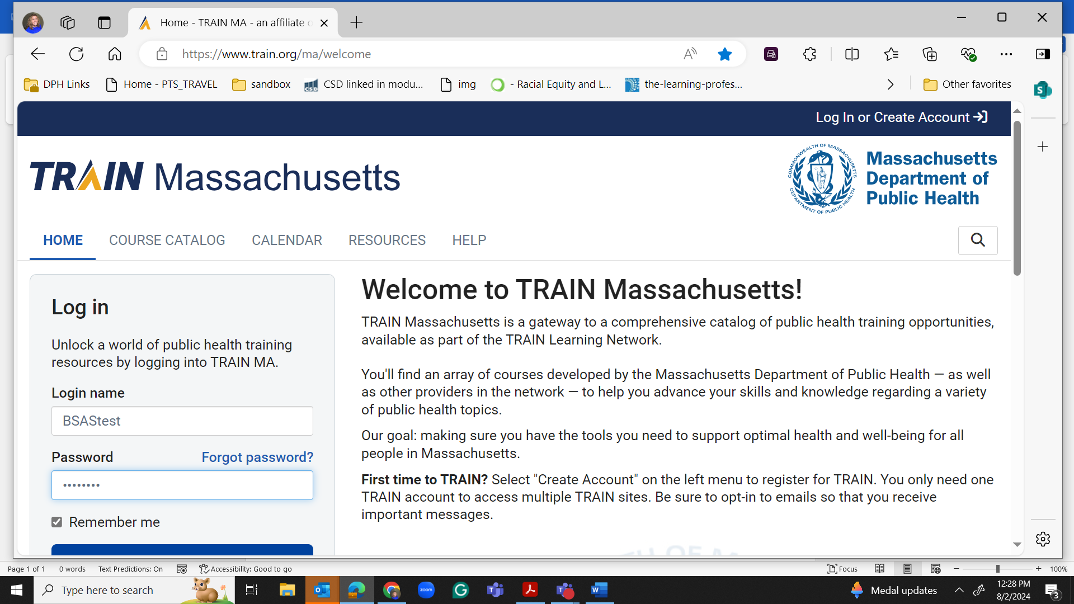
  - Open your web browser and go to TRAIN Massachusetts.

- Create an Account:
  - Click “Create Account” at the top right corner of the homepage.
  - You will be directed to the registration page.
- Fill Out the Registration Form:
  - Enter your personal information: name, email address, and any other required details.
  - Choose a username, which is not an email address, and a password that security requirements.

  - Select Division or Business Unit as one of the following: External DPH Partners: Contractors with the Department of Public Health (DPH) but are external to the organization.
  - General Learner - Non-DPH Partner: General learners not associated with the DPH.
  - Internal DPH Partners: Users working internally within the DPH.

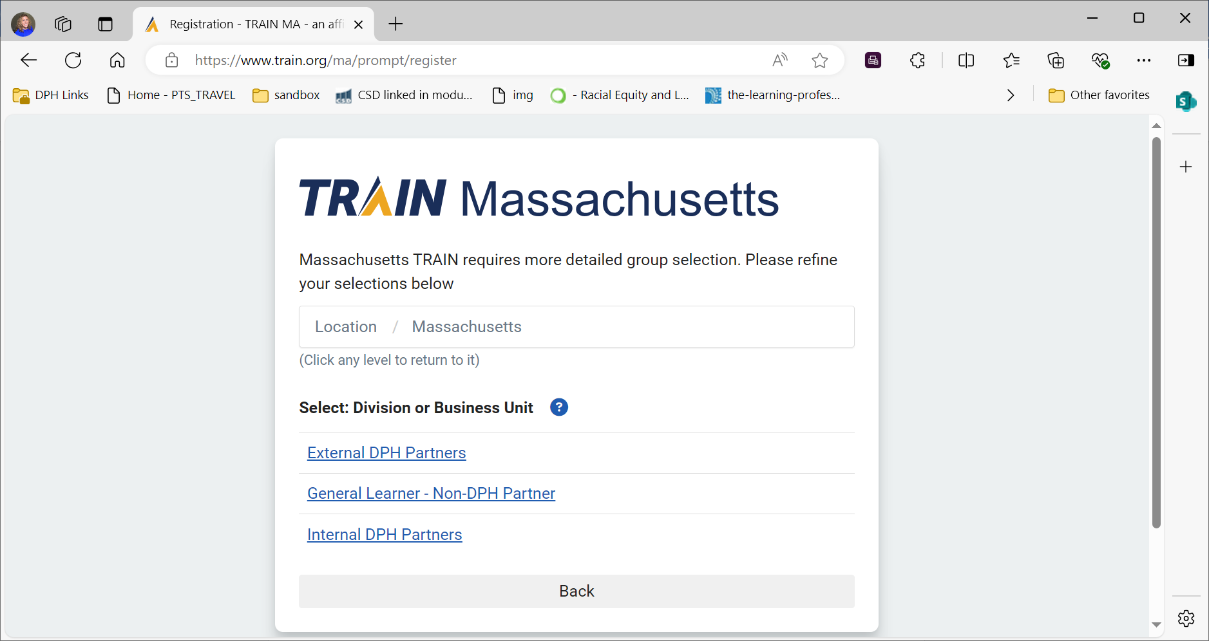
- Complete the Registration:
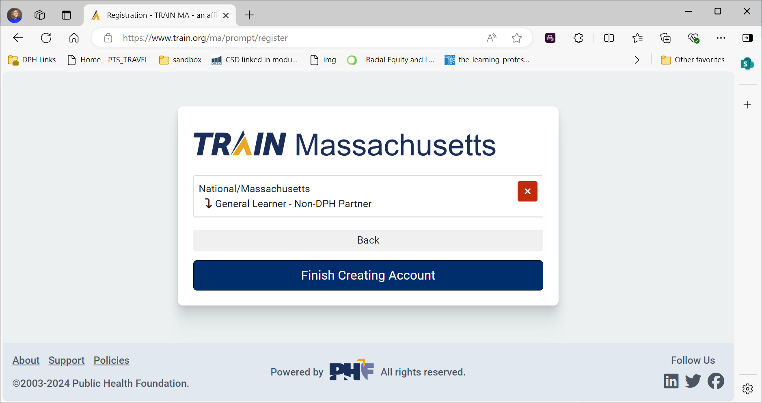
  - Click “Finish Create Account” at the bottom of the form to complete your registration.
  - You will receive a confirmation email. Open the email and click on the confirmation link to verify your email address.
- Log In to Your Account:
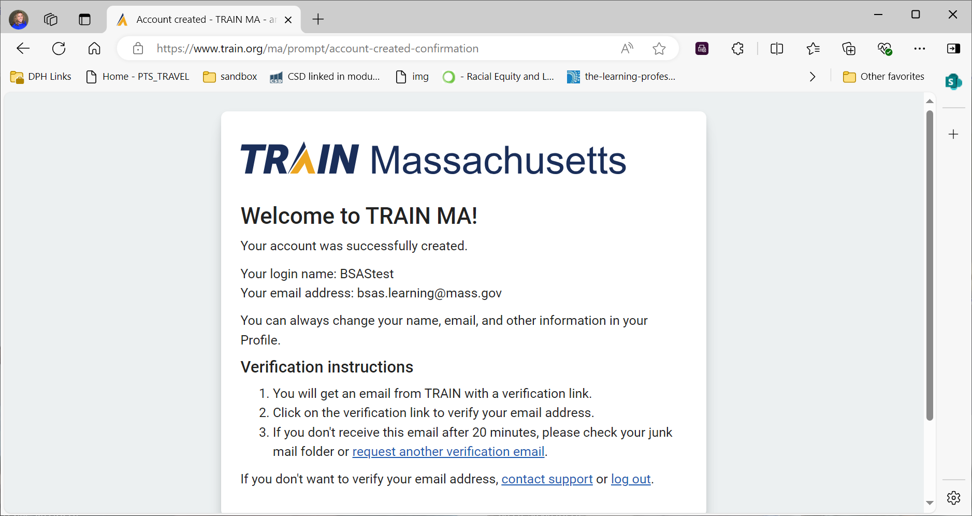
  - Return to the TRAIN Massachusetts homepage.
  - Click on the “Login” button at the top right corner of the page.
  - Enter your username and password in the designated fields.
  - Click “Login” to access your account.
- Update Your Profile:
  - Once logged in, it is recommended to complete your profile by adding additional information such as your job title, department, and contact information.
  - Navigate to your profile settings by clicking your name or profile icon and selecting “Profile” from the dropdown menu.
  - Fill out any remaining fields and save your changes.

- Enroll in Courses:

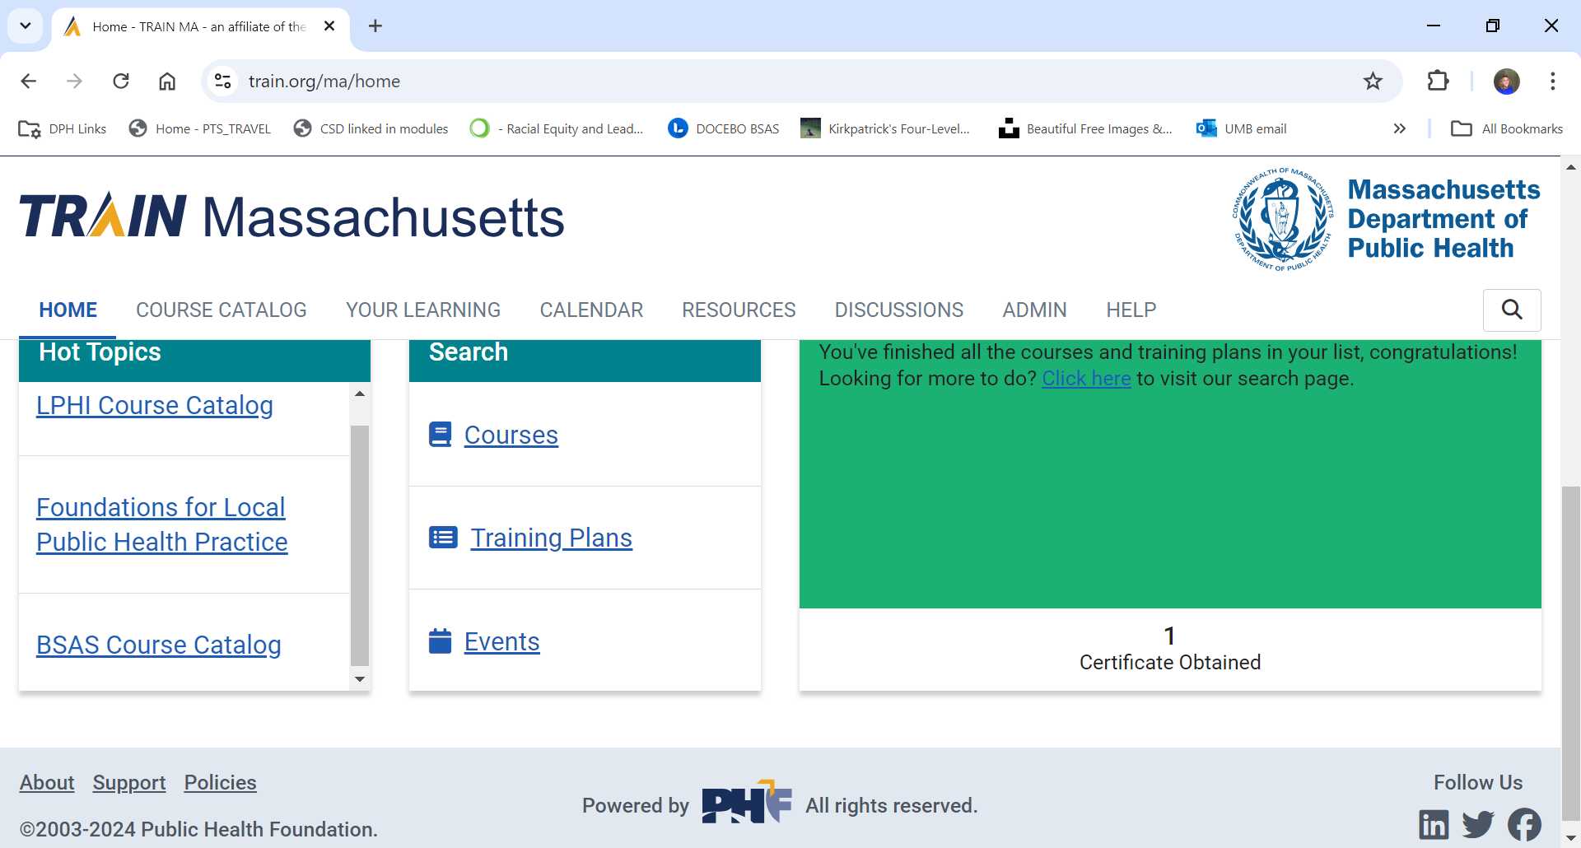
TRAIN is the National Public Health Learning Management System (LMS) that offers a wealth of content.
  - Click on BSAS Course Catalog in Hot Topics
  - Or, Click Courses and search the course by title in the search bar
  - Or, to specifically filter BSAS content, Click on “Organization” and type "BSAS" to view a list of available courses offered by BSAS.

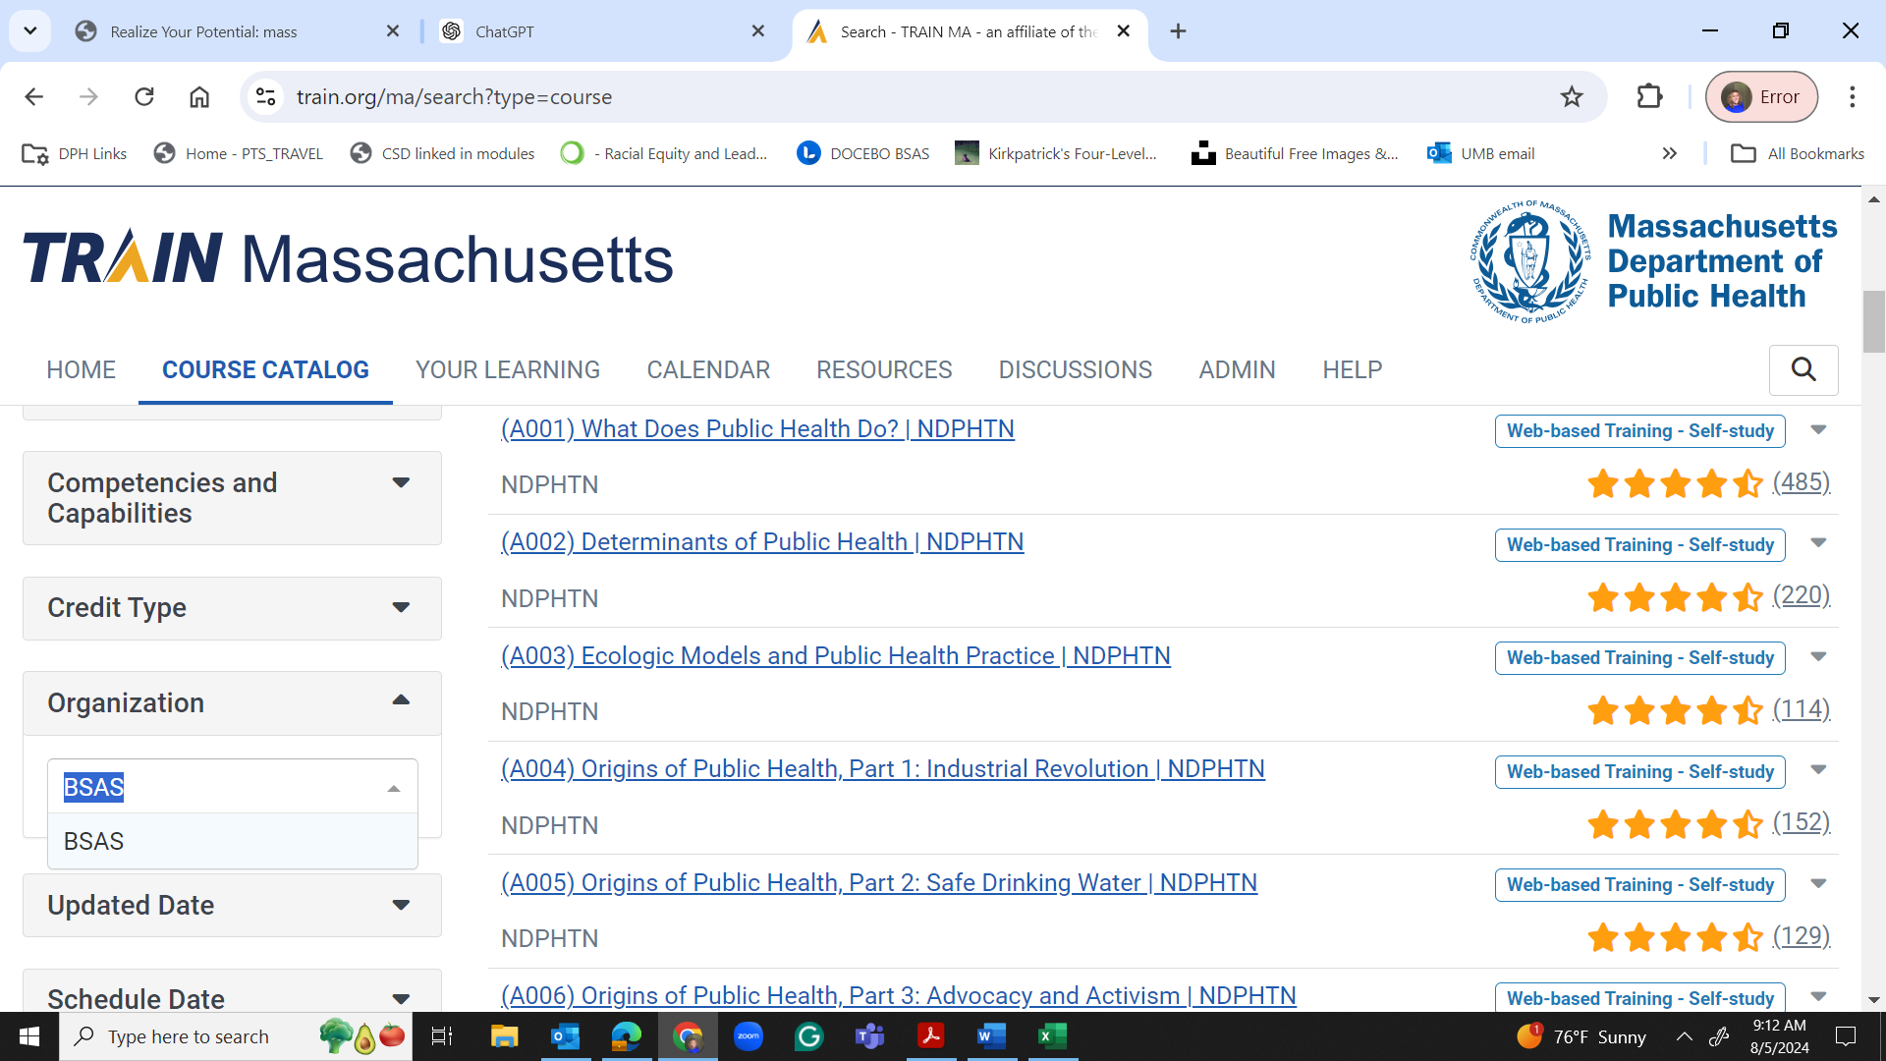

  - Follow the instructions to complete the enrollment process and start learning.
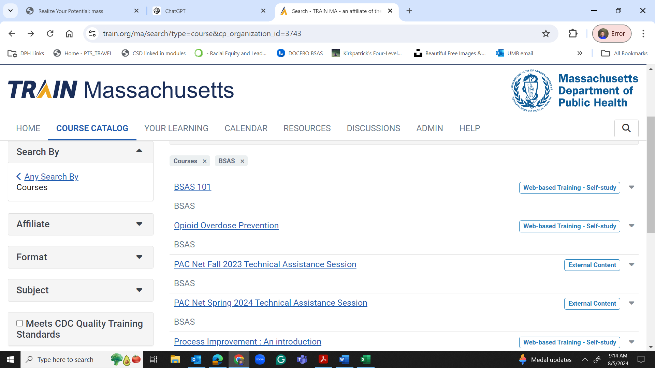
If you encounter any issues during the registration or login process, please get in touch with BSAS.Learning@mass.gov.

